Name:___________________ Number_______
Unit 8 Homework- The Solar System
1. How many planets are in the solar system?
6
7
8
2. What causes sunrise and sunset?
Earth orbits.
Earth rotates.
The sun moves around Earth.
3. This picture shows a model of Earth’s rotation. Earth also moves around the sun. This movement is called an orbit.
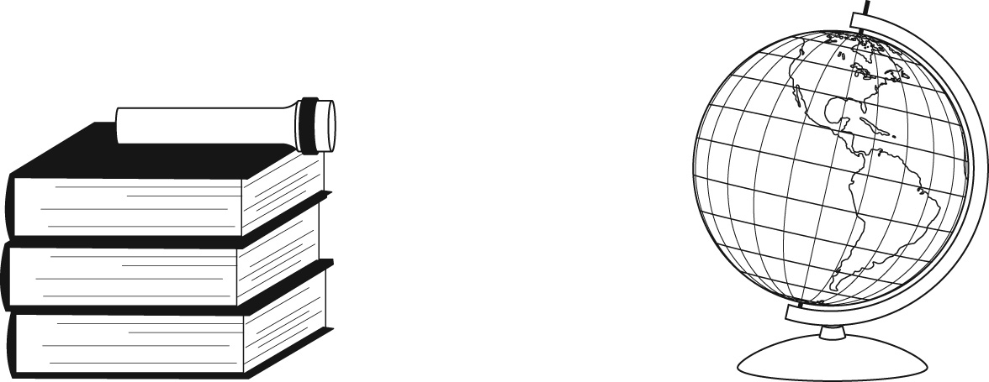
How could you model Earth's orbit?
turn the globe
carry the globe around the flashlight
move the globe closer to the flashlight

