FROG DISSECTION **Name** ____________________________________________



7th Grade

***Objectives****:*

* ***to observe the external and internal anatomy of a frog.***
* ***to determine the sex of a frog by observing the internal anatomy.***
* ***to observe the body systems : integumentary, muscular, digestive, respiratory, circulatory, urogenital,  and skeletal***

**Click to go to these videos: Then, complete this packet.**

**(1)** [**https://youtu.be/cPaHbNEbtNo**](https://youtu.be/cPaHbNEbtNo) **(2)** [**https://youtu.be/9Y8Ysek4Vac**](https://youtu.be/9Y8Ysek4Vac)

**(3)** [**https://youtu.be/9N27Tj3B4k8**](https://youtu.be/9N27Tj3B4k8) **(4)** [**https://youtu.be/8HBgMlpIzEk**](https://youtu.be/8HBgMlpIzEk)

**(5)** [**https://youtu.be/NJFKeNKKhP4**](https://youtu.be/NJFKeNKKhP4)

**Biological Drawings Hints:** Pay close attention!



1. **ALWAYS USE A *PENCIL only!!* With a good eraser.**
2. **Answer ALL questions in order. Pay great attention to detail.**
3. **Make the drawings "larger than life" size, as the specimens are so small.**
4. **Draw the general *shape* (outline) and *location* of the organs, as the squiggles so many of you use to "shade" your drawings make your drawings sloppy and hard to interpret. So do not shade.**
5. **Include Labels on all drawings.**

* **Labels should start *outside* the drawing, and be connected to the structure by arrows with tips The Tip of the arrow should be *touching* the structure being identified.**

**Laboratory Lesson #1 - The External Anatomy** [Use your Frog Sandwich pkt for help]

1. Observe the dorsal and ventral sides of the frog. Dorsal side color ___________ Ventral side color ____________

2. Examine the hind legs. How many toes are present on each foot? ______ Are they webbed? _________

3. Examine the forelegs. How many toes are present? ________ Are the toes webbed? _______

4. Males have an enlarged thumb-pad on the forelimbs. Is your specimen male or female? _______________

4. Use a **ruler** to measure your from the tip of the head to the end of the frog's backbone. Compare the length of your frog to other frogs at your table:

|  |  |  |  |  |
| --- | --- | --- | --- | --- |
| Your Frog (cm) | Frog 2 | Frog 3 | Frog 4 | Average length (cm) |
|  |  |  |  |  |

5. Locate the frog's eyes, the nictitating membrane is a clear membrane that attached to the bottom of the eye. Use tweezers to carefully remove the nictitating membrane. You may also remove the eyeball.

What color is the nictitating membrane? _____________ What color is the eyeball? _________________

6. What do you think is the function of the **nictitating membrane** over the eyes, and why?_____________________

_____________________________________________________________________________________________

7. Just behind the eyes on the frog's head is a circular structure called the tympanic membrane. The tympanic membrane is used for hearing. Measure the diameter (distance across the circle) of the tympanic membrane. Diameter of tympanic membrane = ___________cm

8. Feel the frog's skin. Is it scaly or is it slimy? ____________

**Lesson #2 - The Mouth** [ Use your Frog Sandwich pkt for help]

* Pry open the mouth with the probe.

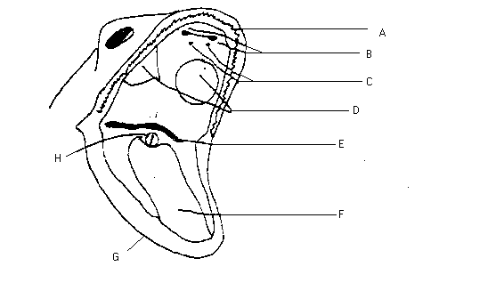

* Loosen the jaw by cutting on each side of the jaw with the scissors.

1. Label these internal structures of your frog’s mouth.

**Answer these questions.**

1. Locate the tongue. Play with the tongue.

Does it attach to the front or the back of the mouth? ______________

(You may remove the tongue).

1. Draw a sketch of the tongue, paying attention to its shape. Tongue Sketch:
2. How many **vomerine teeth** does your frog have? _______________ A frog does not chew its food. What do the positions of its teeth suggest about how the frog uses them?__________________________________________
3. How many internal nares openings can you find in the mouth? ________________
4. What part of the mouth are the maxillary teeth found in? _____________________
5. What are the two round bumps that are found on the right and left sides of the

frog’s upper jaw ( roof of its mouth)? ____________________________________________________________

1. In the center of the mouth, toward the back is a single round opening, the esophagus. This tube leads to the stomach. Use a probe to carefully poke into the esophagus.
2. Close to the angles of the jaw are two openings, one on each side. These are the Eustachian tubes. They are used to equalize pressure in the inner ear while the frog is swimming. Insert a probe into the Eustachian tube.

To what structure does the Eustachian tube attach? ____________________

# **DISSECTION AND EXAMINATION OF FROG’S INTERNAL ANATOMY**

## Laboratory Lesson #3 – The Internal Structures of the Frog



* Turn the frog over on its back. Using 4 dissection pins pin each hand and foot to the dissecting tray.
* Using the forceps, scalpel, scissors, cut the frog’s skin, with an –shaped cut. Be careful to cut one layer at a time.
* Pin the skin to the sides or remove by cutting
* Cut the chest muscles the same way as the skin.
* Pin or remove the chest muscles.

**CIRCULATORY SYSTEM**

**HEART**

1. **Draw** the parts of the liver and the heart as you see them in the frog.

**Do not cut out the heart yet.**

1. Find the **left atrium, right atrium, and ventricle** of the heart.

Find an **artery** attached to the heart and another artery near the backbone.

Find a **vein** near one of the shoulders. Find the **two lungs**.

**Trace the path of blood through the circulatory system,**

**starting at the right atrium,**

**LIVER**

1. What color is the liver? _____________________________
2. How many parts, or lobes, does the liver have? ____________________________
3. What organ of the frog’s body is located directly above the middle part of the liver? ___________________

## GALL BLADDER

## Gall bladder is attached to the back surface of the liver. Lift up the liver to locate it.

1. What color is the gall bladder? **___________________________________**
2. Open up the gall bladder. Was it filled with liquid? ______________________________
3. What organ was the gall bladder found under? __________________________________

**DIGESTIVE SYSTEM**

* **If you have a female frog with ovaries containing eggs, carefully remove the eggs before going on.**

**ESOPHAGUS**

1. Where does the esophagus start? ______________________________________________
2. Where does the esophagus end? _______________________________________________
3. What color is the esophagus? ________________________________________________

**PANCREAS**

1. What color is the pancreas? ________________________________________________
2. What 2 major parts of the digestive system is the pancreas attached to?

____________________________ and _______________________________________

**STOMACH**

* **Lift the left lobe of the liver to find the stomach**

1. What color is the stomach? _____________________________________________________
2. What 2 parts of the digestive system is the stomach connected to?

____________________________________ and _____________________________________

* **Remove the stomach from the frog, lay in one corner of pan.**

1. Draw the shape of the frog’s stomach:

1. Touch the stomach. Describe how it feels. ______________________________________________

* **Using the scissors carefully cut the stomach open lengthwise. Spread it open and pin it down on the dissecting tray.**

1. Does the stomach have anything in it? ____________

If yes, what did you find? _______________________________________________________________________

1. What does the internal lining of the stomach look like? ____________________________________________
2. Where does the food go after the stomach? _____________________________________________

## SMALL INTESTINE

1. Is the small intestine straight or coiled? _______________________________________________

* **Remove the small intestine from the frog. DON’T REMOVE THE LARGE INTESTINE YET.**
* **Stretch the small intestine out so it is straight and pin it down.**

1. How long, in centimeters, is the small intestine? The small intestine is _______ cm

* **Cut the small intestine open lengthwise.**

1. Was there anything in the small intestine? ________

If yes, what did you find? ______________________________________________________________

1. Where does the digested food go after the small intestine? _________________________________

**LARGE INTESTINE**

1. Is the large intestine straight or coiled? _________________

* **Remove the large intestine from the frog. Cut the large intestine open lengthwise and pin it down.**

1. Was there anything in the large intestine? ______

If yes, what did you find? ______________________________________________________________

**CLOACA**

1. Where is the cloaca located? _______________________
2. The cloaca is a chamber for receiving 3 things: ______________________ , ____________________,

and ______________________.

**Trace the path of food through the digestive tract.**

**FAT BODIES** *If your frog has them, answer these questions.*

1. Does your frog have fat bodies? _________ If yes, what color are they? __________________
2. After looking at the amount of fat bodies in your frog, what season of the year do you think your frog died? _____________________Explain__________________________________________________________
3. What are fat bodies used for? _______________________________________________________________
4. Where are the fat bodies attached in your frog? _______________________________________

* **LIVER**… *Observed earlier.* **NOW Remove the lobes of the liver from your frog.**

**RESPIRATORY SYSTEM**

**LUNGS**

* **The lungs are to the left and right of the heart in the chest area.**

1. **Draw the heart and lungs:**
2. Remove a lung and cut it open lengthwise. **Draw** what you see:
3. **Trace the path of air through the respiratory system. Start at Nostrils, then ________________________________**

**EXCRETORY SYSTEM**

**KIDNEYS**

1. Draw the shape of the kidneys in your frog.:

How many are there? ___________

URINARY BLADDER

1. Where is the urinary bladder located? __________________________
2. **REPRODUCTION**Do you have a male or female frog? _____________________________

**IF YOU HAVE A MALE FROG do #39 & #40: IF YOU HAVE A FEMALE FROG do #41 & #42**39. Where are the testes located? 41. Where are the oviducts located?

___________________________________________ ________________________________________

40. Draw the kidneys and testes: 42. Draw the kidneys and oviducts:

* **Trace the path of urine and eggs or sperm in either: Start at renal arteries, kidney, …**

**ANALYSIS:**



1. **Discuss:** How are the organs of a frog are similar to the organs of a human. How different?

**2. CONCLUSION:** **Write 5 sentences on what new things you learned today.**

1.

2.

3.

4.

5.

**3. Label the diagram:**

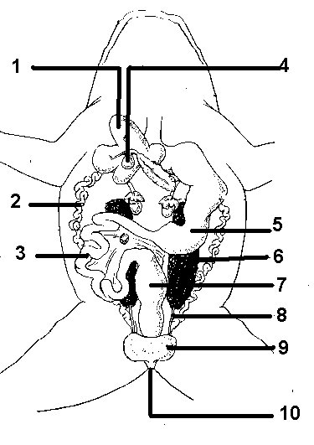

**GOING FURTHER…...  
IF YOU HAVE TIME: Carefully remove the skin and muscle from the legs, the eyeball and SKULL  
Check them off after you do them.**

_____ Thighbone: skin and muscle removed, thighbone visible

_____ Eyeball removed

_____ Brain exposed

_____ Spinal cord exposed

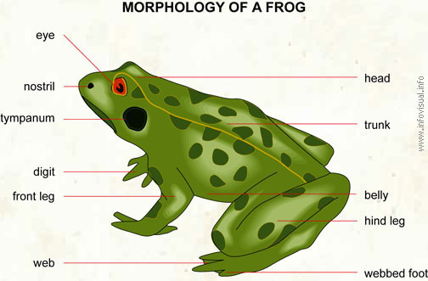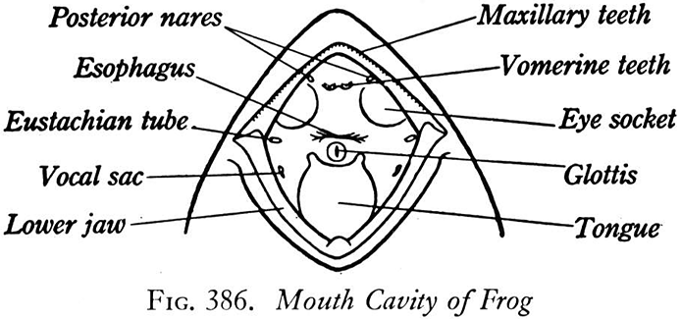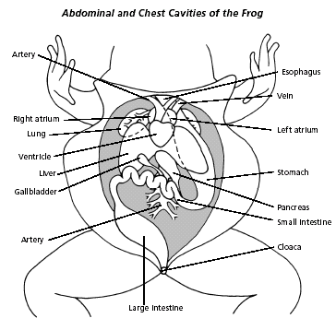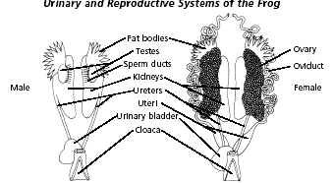

**WHEN YOU ARE FINISHED**….  
1. Look at board. Follow directions for cleaning up.

2. Throw away paper towel and frog body parts in the specified container.  
3. Clean up your table.

4. Throw away your gloves.

5. Return your goggles and apron neatly to their respective containers  
6. Turn in Frog Dissection Packet.  
7. **Go wash hands and arms thoroughly with soap, several times.**

ENJOY YOUR SUMMER BREAK! LEARN ALL YOU CAN!

See You Next Year!